**Case Study: Create a jupyter notebook instance in AWS SageMaker. Copy the git repo code and put it inside the folder.**

1. Create the notebook instance

GO TO SageMake. Then Notebook. Create notebook instance:

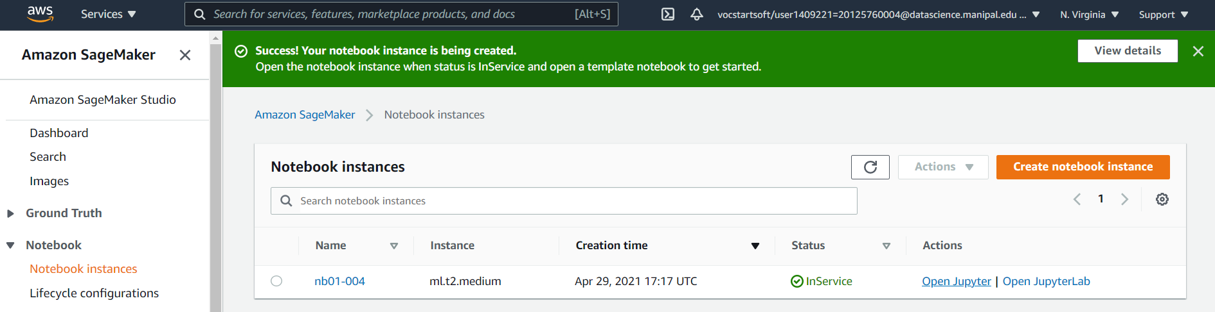

1. Clone the git repo code in the SageMaker notebook instance:

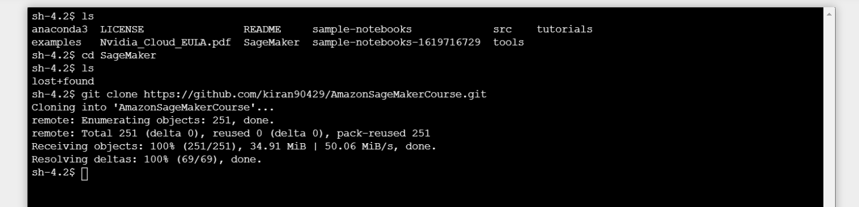

1. Put it inside the folder:

